SCIENCE CLASS TEST
Full marks-10
- Objective questions - (3 marks)
- Assertion (A): All invertebrates have skeleton.
Reason (R): Vertebrates are animals that lack a backbone.
    - Both A and R are true, and R is the correct explanation of A.
    - Both A and R are true, but R is not the correct explanation of A.
    - A is true, but R is false.
    - A is false, but R is true.

- Assertion (A): Fish have gills for breathing.
Reason (R): Gills help fish extract oxygen from water.
    - Both A and R are true, and R is the correct explanation of A.
    - Both A and R are true, but R is not the correct explanation of A.
    - A is true, but R is false.
    - A is false, but R is true.

- Observe the given image.
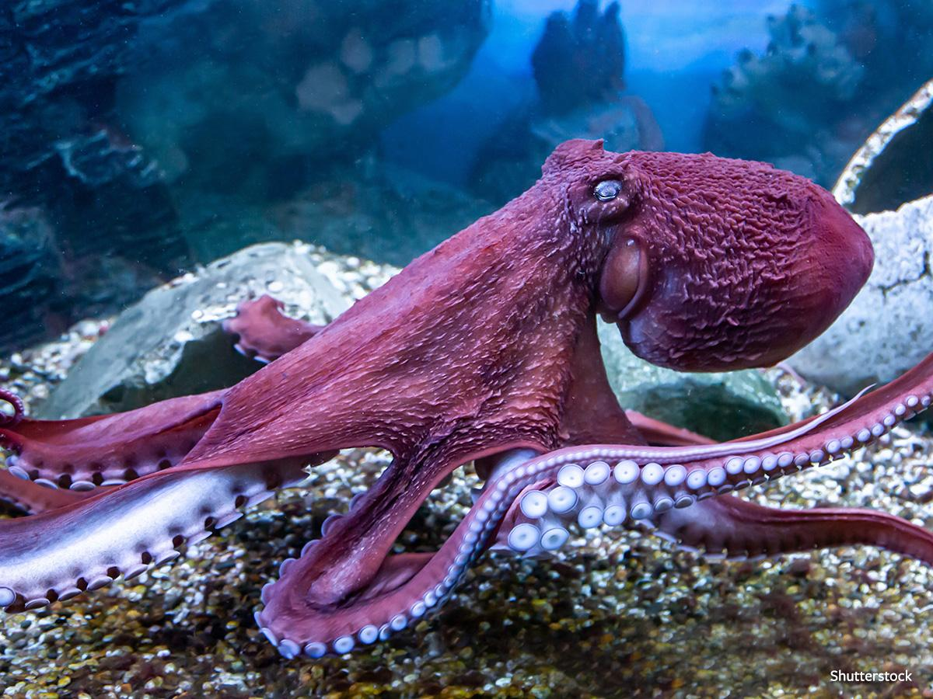
Choose the correct combination for the given animal.
- Amphibian, invertebrate, viviparous
- Vertebrate, oviparous, aquatic
- Invertebrate, aquatic, oviparous
- Viviparous, aquatic, invertebrate

- Subjective questions - (7 marks)
- Tina finds an earthworm and a frog in her garden. The worm has a soft body, and the frog has moist skin. . (1+2=3 marks)
- Classify the animals based on their habitat.
ii.Classify which one is vertebrate and invertebrate. Justify your answer with proper reason.
- On a school trip to a zoo: (1+1=2marks)
i. Students saw Animal P hatching from an egg.
ii. They also saw Animal Q carrying babies in its pouch.
      - Identify the type of reproduction in both animals.
      - Give one example of both type of animals.
- Rohan touched a camel’s skin and found it very dry and thick. He wondered why camels have such skin. Explain how this skin helps the camel in its desert habitat. (2marks)

